10/22/2026
LAB NO 07
Operating System Lab
Instructor: Ms. Muneeba Banaras
Submitted By: Wasif Ali
Reg ID: 245187
Class: BSCS F’24 B

LAB TASK
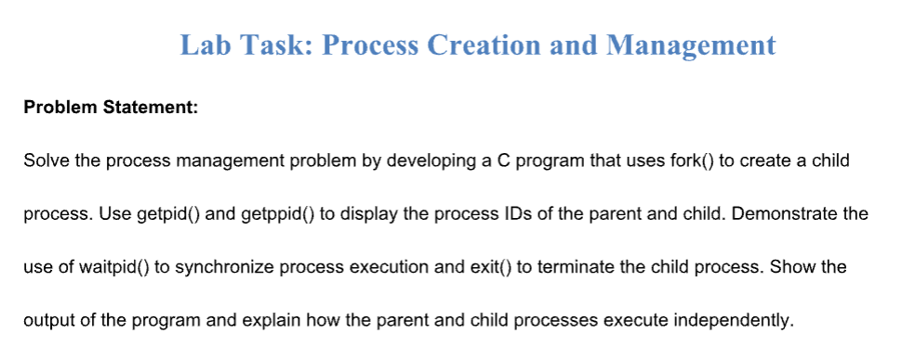
Code/Commands:
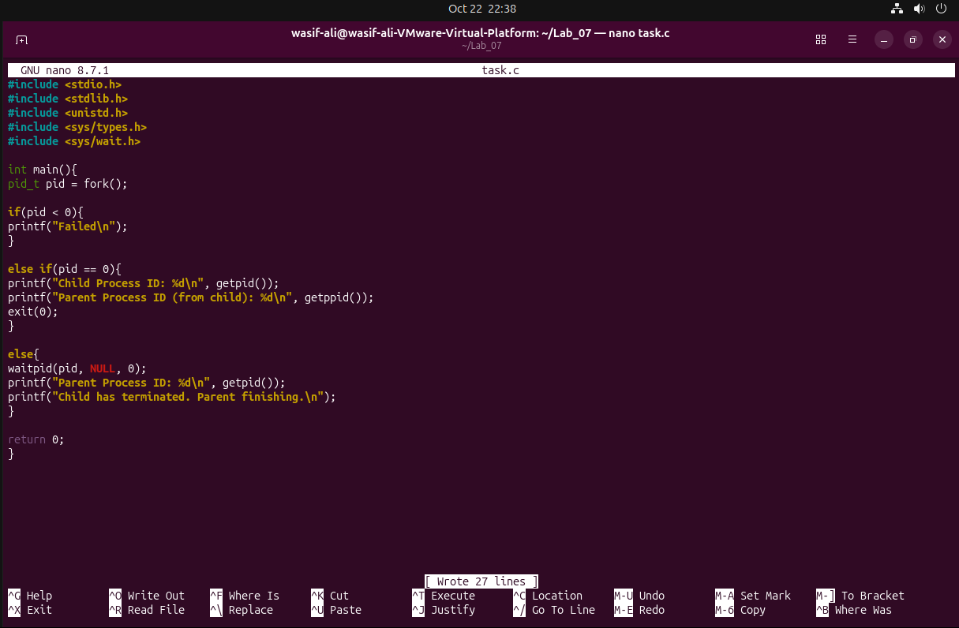

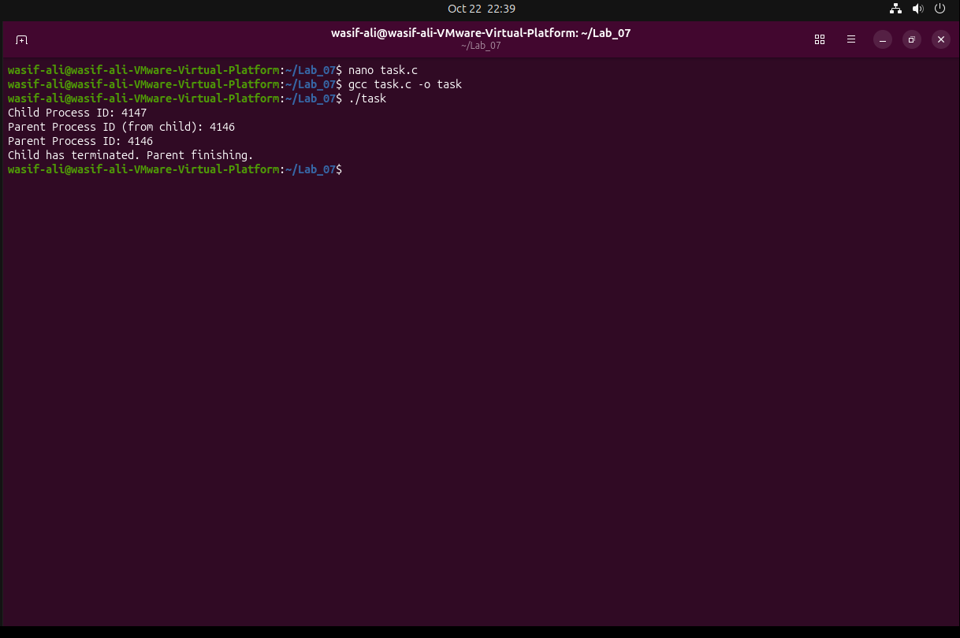

In this final task, we combined everything we learned about process management. We created a C program that uses fork() to spawn a child process. Inside the child process, we displayed its own PID and its parent's PID using getpid() and getppid(), and then safely terminated it using exit(0). In the parent process, we used waitpid() to ensure the parent pauses and waits specifically for this child to finish before printing its own PID. Parent and child processes execute independently because they run in separate memory spaces; the operating system treats them as distinct tasks, but by using waitpid(), we successfully forced them to synchronize their execution.

